**CS512 Final Project**

**Kernel-Based Object Tracking**

Miguel Menendez Alvarez A20363536

Jiranun Jiratrakanvong A20337992

Department of Computer Science

Illinois Institute of Technology

Nov 18, 2015

**Abstract**

This report is based on the implementation of the algorithm described in the paper *Kernel-Based Object Tracking* by Dorin Comaniciu, Visvanathan Ramesh, and Peter Meer. It was published in May 2003 by IEEE *Transactions on Pattern Analysis and Machine Intelligence*. It will be explained the approaching of this paper to the object tracking problem as well as the implementation made using Python supported by OpenCV and Cython parts.

# Introduction

Nowadays, real-time non-rigid object tracking is one of the most important task in computer vision application. This task is necessary in several applications such as surveillance, augmented reality or, the most famous topic now, driver assistance. It could be a critical part of the system, however, we need to minimize system resource usage of tracking because the resource is also required for other processing such as recognition, trajectory interpretation, and reasoning. Therefore, we need an approach that can perform non-rigid object tracking accurately and efficiently.

Kernel-Based Object tracking is one of real-time non-rigid object tracking method. The approach is based on *target representation* using the feature histogram and regularized by spatial masking with an isotropic kernel, and *target localization* using the basin of attraction of the local maxima. The smoothness of the similarity function allows application of a gradient optimization method which yields much faster target localization compared with the (optimized) exhaustive search.

The similarity measure is calculated by a metric derived from Bhattacharyya coefficient, having the meaning of a correlation score in this implementation, and the optimization is performed by the mean shift procedure. Moreover, this approach coped with camera motion, partial occlusions, clutter, and target scale variation.

We will conduct a program which can perform Kernel-Based Object tracking by using Python with OpenCV. After the tracked object is specified at the first frame by a user, the program will perform the tracking algorithm at all following frames.

# Algorithms and codes

The algorithm used has several steps that will be explained briefly.

* Initialize the location of the target in the current frame and compute its representation
* Find the next location of the target candidates
* Compute the representation of the candidates
* Search and find the best candidate (less difference of representations)

**Target representation**

The representation in this program is calculated by a probability density function (pdf) which is color pdf of target.

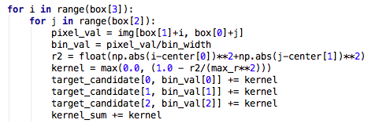

*Part of get_pdf function*

The function will iterate each pixel in selected area (target model), and get the color proportion according to number of bins. For example, if there are 4 bins, and the area are all red. The pdf of this area will be

B: (1.0, 0.0, 0.0, 0.0)

G: (1.0, 0.0, 0.0, 0.0)

R: (0.0, 0.0, 0.0, 1.0)

Moreover, an isotropic kernel, with a convex and monotonic decreasing kernel profile, assigns smaller weights to pixels farther from the center. The pdf will be calculated at the first time as *Target Model* when the target area selected by a user. Then, the pdf will be calculated on the next frame as *Target Candidates*. Therefore, we have two pdf or m-bin histograms which are

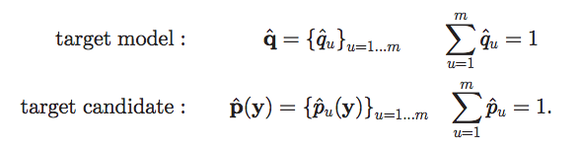

**Metric Based on Bhattacharyya Coefficient**

In order to compare two targets, it is needed to define a metric which represents the distance between, in this case, two distributions. This metric is based on the Bhattacharrya Coefficient and it is defined as:

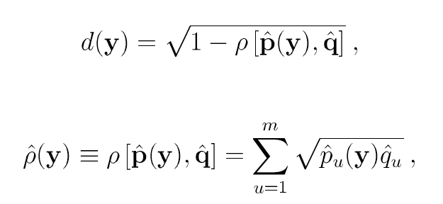

This metric has valuables properties to be considered for this purpose as it could be see with more detail in the referenced paper.

**Target Localization**

In order find the location corresponding to the target in the current frame, the distance between target model and target candidate in current frame should be minimized. However, before the distance minimization, weights {wi}i=1..n should be derived according to

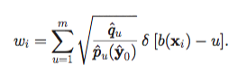􏰋 *(is the Kronecker delta function)*

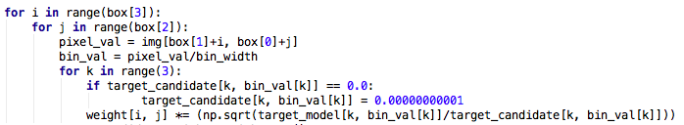*Weights calculation*

Weights of each pixel in the area will refer to the similarity between that pixel and the target model, so the program will able to approximate the direction of target moving. For example, if the selected area is a 5x5 box, and its weights are:

|  |  |  |  |  |
| --- | --- | --- | --- | --- |
| 50 | 20 | 0.1 | 0.1 | 0.03 |
| 20 | 5 | 0.01 | 0.001 | 0.0001 |
| 0.1 | 0.02 | 0.001 | 0.001 | 0.0002 |
| 0.001 | 0.01 | 0.0001 | 0.001 | 0.0003 |
| 0.001 | 0.001 | 0.0001 | 0.001 | 0.0005 |

The direction of target moving tends to be upper left. The box will move to that direction, then re-calculate the target candidate and weights again. The program will redo these process on each frame until either the target model and target candidate are similar or the MAX_ITER exceeded. How similar of the target model and target candidate can be distinguished by distance minimization (the direction of target moving is small).

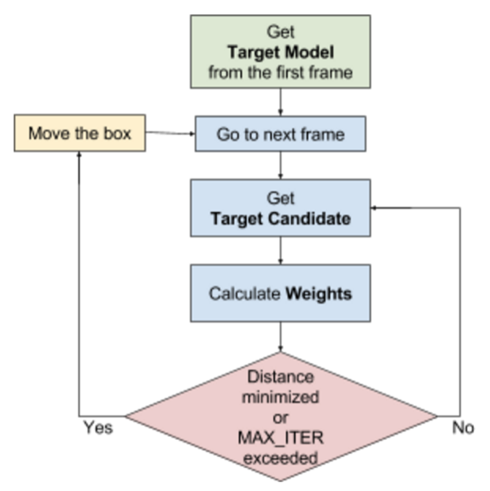

*Flowchart of process overview*

# Implementation Details

**Problems and Solutions**

According to the searching best candidate process, the tracking process was very slow. It might take almost 5 seconds per frame. It also depends on the size of target. The solution is making a new parameter, MAX_ITER, to limit the maximum iterations per frame. This solution solved the very slow problem, but the program was still slow because it is implemented via Python. The second solution is using Cython.

Cython allows to implement the most heavy part of the algorithm through compiled code. This part is the computation of the color pdf and weights of the target candidate where the speedup is about 4-5 times.

Another issue is related to the ‘box’, i.e., the rectangle of the image to track, when it goes through the edge of the image. This problem could be solved in many different ways, e.g. changing the size of the box cutting the outside part, completing with some values the non-image part or limiting the box movement to the edge of the image. The solution taken is the last one, limiting the box to the edge avoid having computation problems and maintain the rest of the algorithm.

**Instructions for using the program**

* Start the program by using command line: python main.py
* After started, the program will ask you to provide the video name.
* After the video name entered, the first frame of the video will be shown. You have to select the tracking target, by drawing a rectangle cover the object using the mouse.
* After a target have been selected, the program will perform tracking through the entire video.
* While the tracking is processing, you can press
  + ‘s’: stop the tracking process in the present video and start again
  + ‘h’: help
  + ‘ESC’: exit the program
* After tracking process has been done, you can enter another video name to do the Kernel-Based Object Tracking again, or enter ‘exit’ to exit the program

# Results and discussion

As it was described before, the program functionality is simple. First, the user selects the object or zone to track and if it is a valid area it will start the tracking process.

* **Selecting tracking target**The selected area will be a green rectangle.

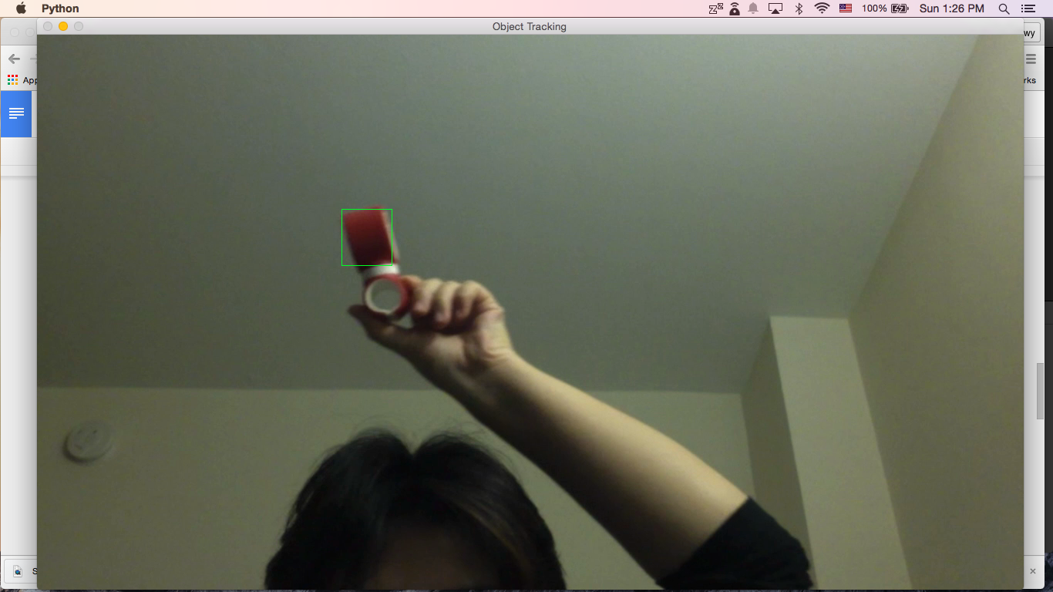

* **Tracking**The green rectangle will move in the direction corresponding to the target.

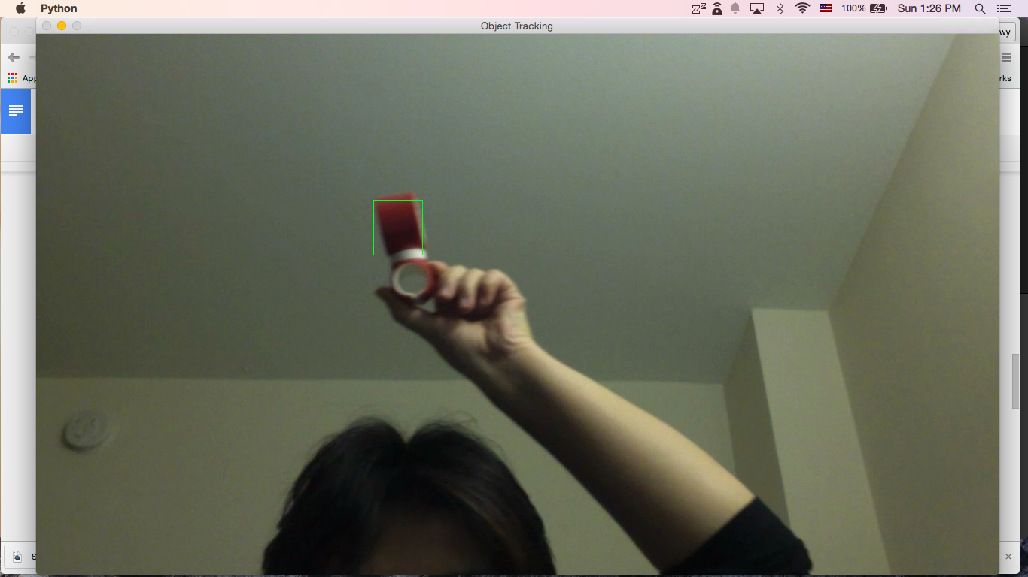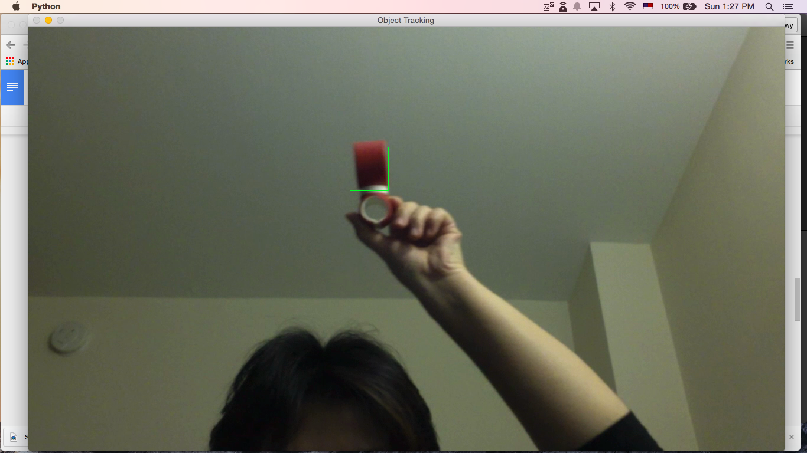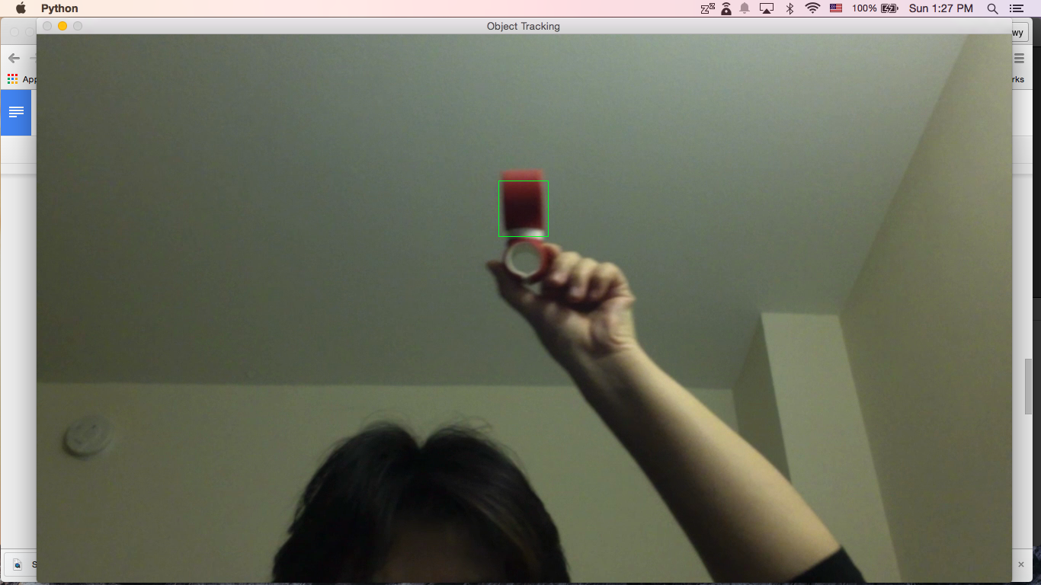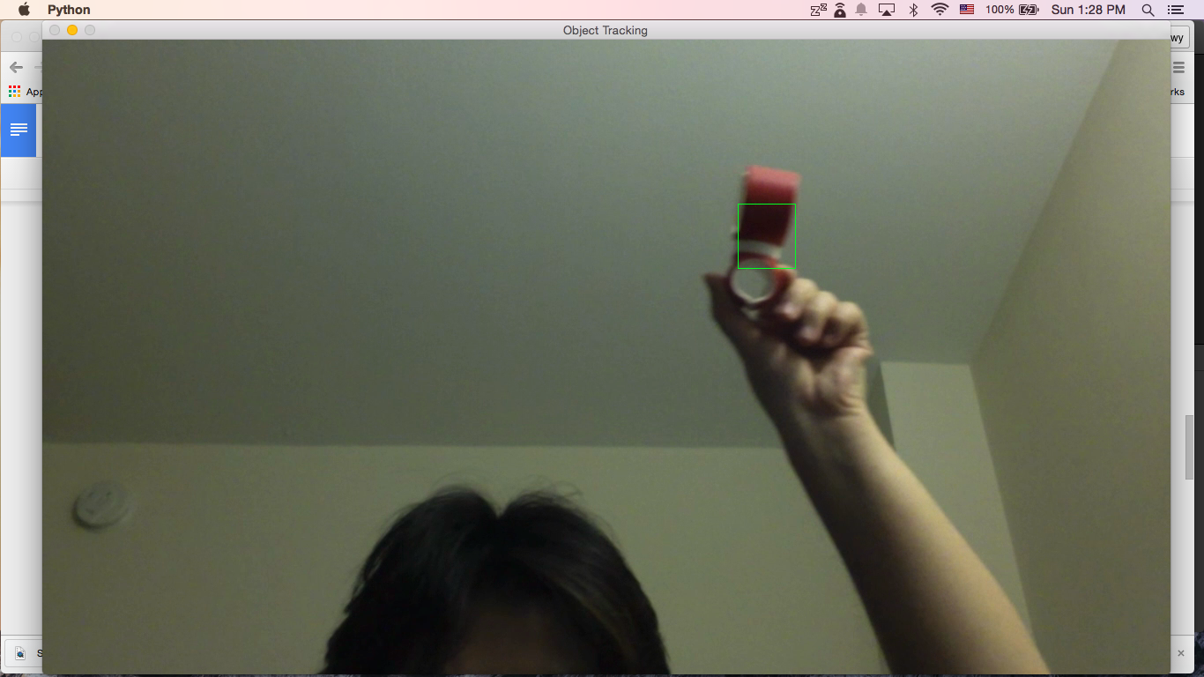

**Strength and weaknesses**

The main strength is how adaptive is the algorithm to changes in the image due to the always changing target model. By updating the model in each new processed frame, the algorithm uses the small changes between consecutives frames to tolerate the big changes that can occur in a long sequence.

This implementation, as the one used in the referenced paper, uses a pdf of the image’s color because it is more than enough for our purposes, but allow us to use other features to compute the similarity of two image boxes if it is required.

The principal weaknesses of this implementation are derived by the low performance that Python offers for intense computing tasks, although Cython improves significantly this performance. The low performance make that the frame rate of the video is not a real-time tracking for videos over 8 frames per second (fps) in most of the cases.

Another weakness is derived from using the pdf of the color, this algorithm is based on the assumption that there are only small changes between frames so if there is a high contrast between two frames, e.g. a person going from a sunny street to a building shadow, the algorithm can lose the target.

**Evaluation**

The program will be tested by simple videos of objects moving in front of the camera as well as complex videos where the target is not that clear such as surveillance camera videos.

For the sample video, we tested by using a video of objects moving in front of the camera.



For the complex video, we tested by using a video from Shibuya crossroads in Japan. The target was a woman with pink bag.

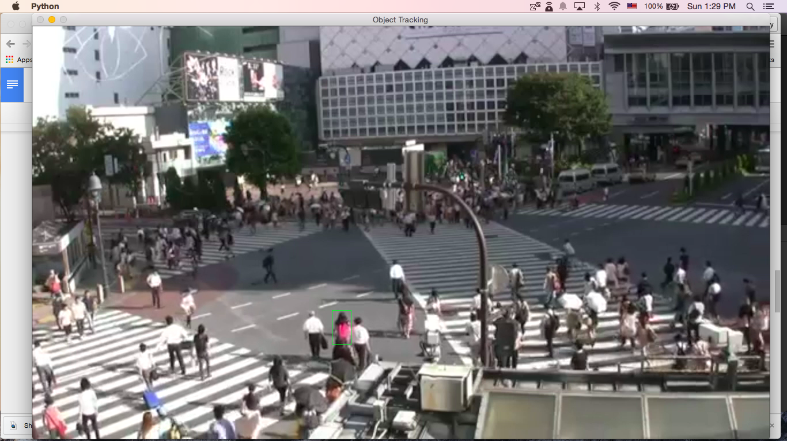

The tracking works well. However, the error tracking occurred when the woman walked under the shadow because the color changed.

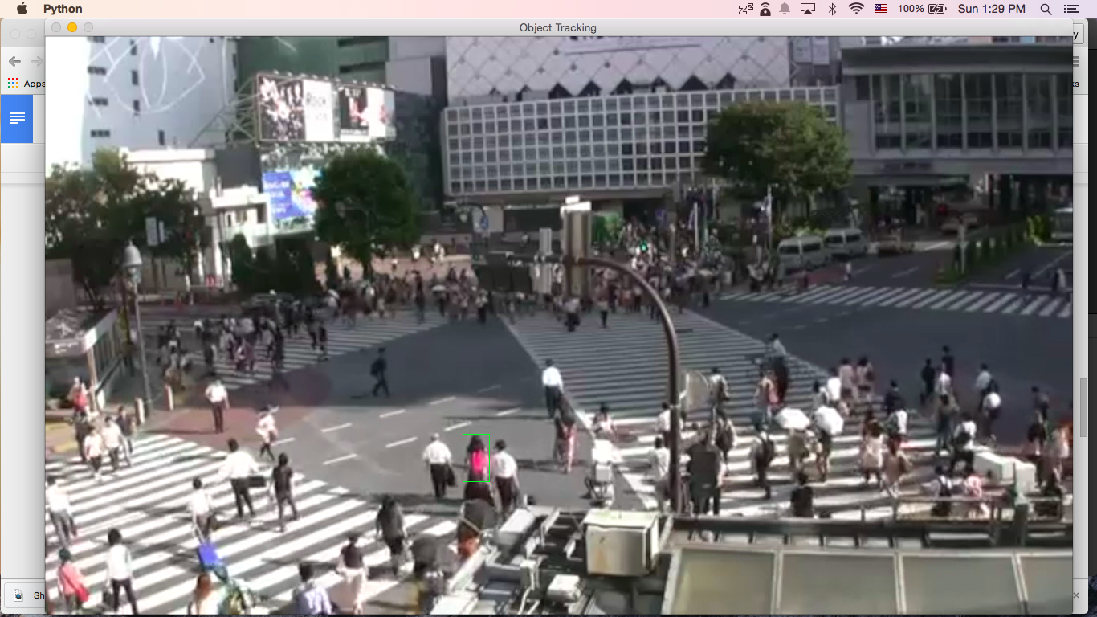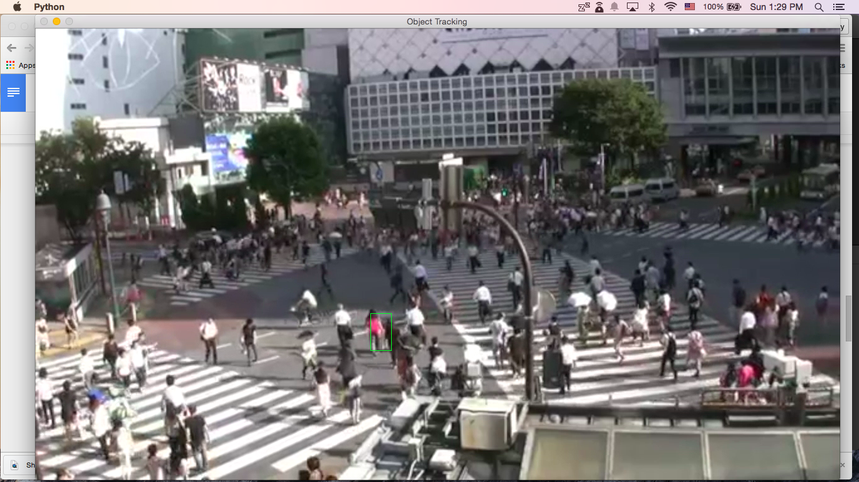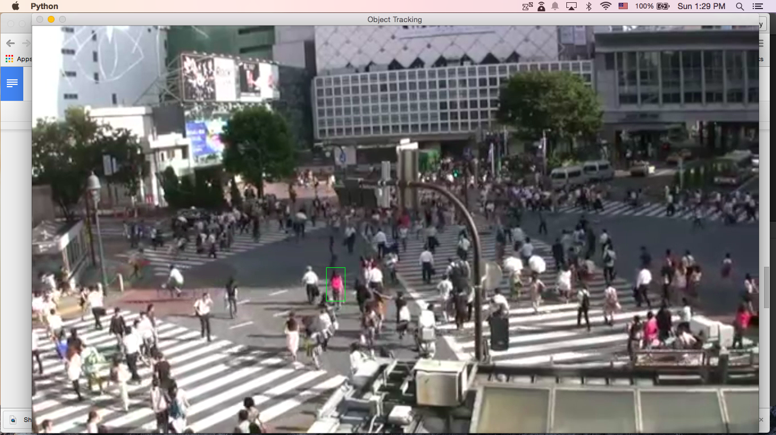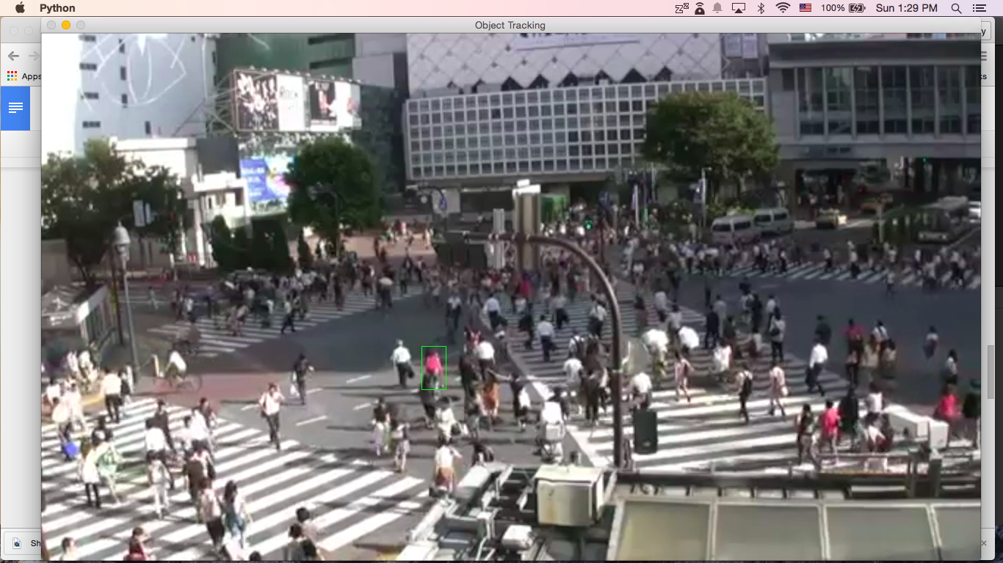

A stable video has been tested for reliable as well. The selected area is just random area on the stable video. The tracking needs to be stay still until the last frame of the video.

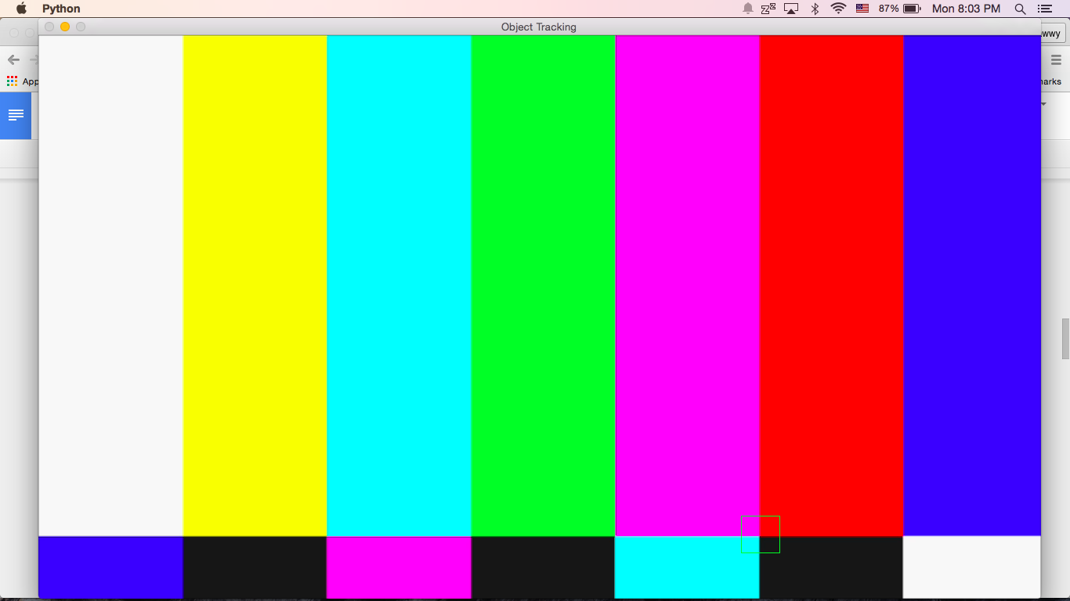

# References

- *Kernel-Based Object Tracking* by Dorin Comaniciu, Visvanathan Ramesh, and Peter Meer

<http://web.eecs.umich.edu/~silvio/teaching/EECS598/papers/kernel_based_object_tracking.pdf>

- Shibuya crossroad - Carrefour de Shibuya - 渋谷 - Tokyo (shibuya.mp4)

<https://www.youtube.com/watch?v=VRhDmrV8ldQ>